CSA1606 – DWDM
LAB PROGRAMS
KAVINILAVU.S(192565038)

EXPERIMENT - 1

AIM:
To write/prove the R program for addition using RStudio.

PROGRAM:
num1 = as.integer(readline(prompt = "enter the first number:"))
num2 = as.integer(readline(prompt = "enter the second number:"))
num3 = num1 + num2
print(num3)

OUTPUT:
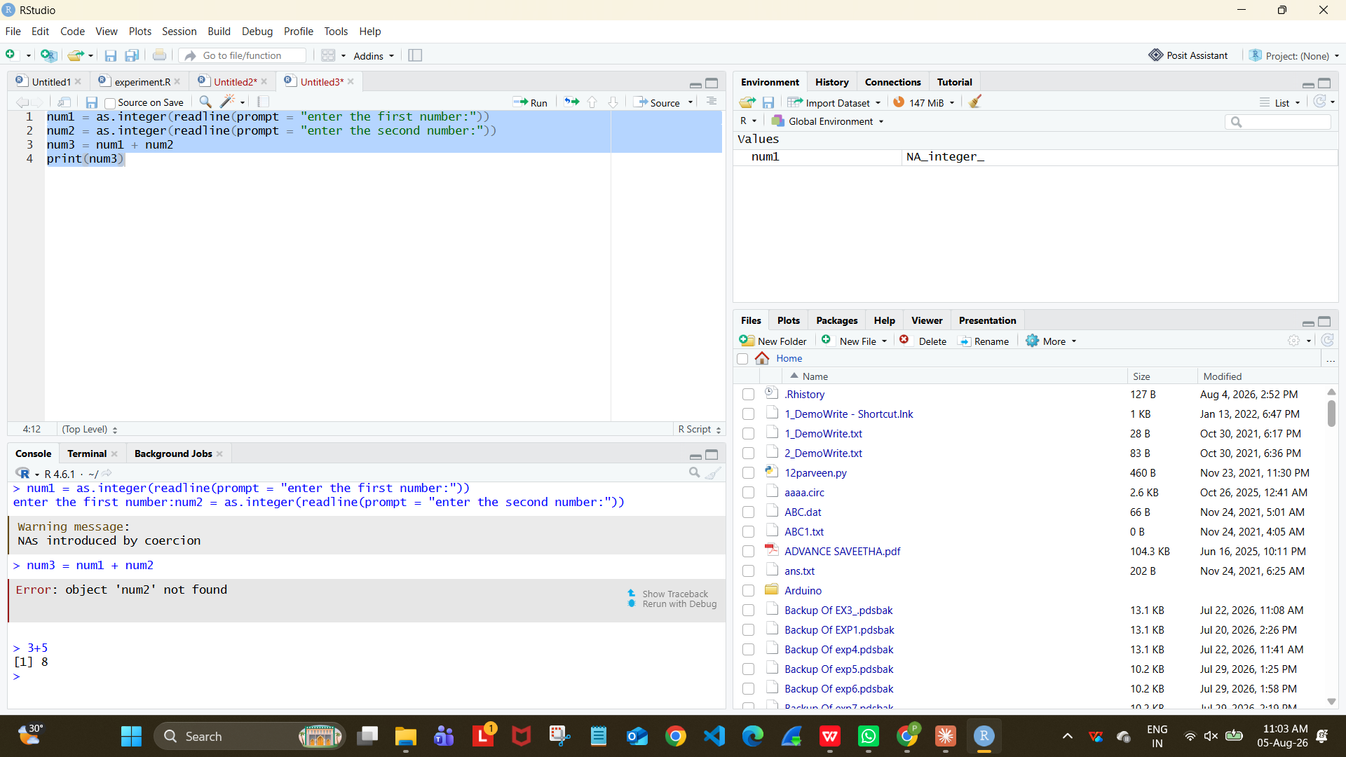

RESULT: Thus the R program for addition was executed successfully.

EXPERIMENT - 2:

AIM:
To write/prove the R program for subtraction using RStudio.

PROGRAM:
num1 = as.integer(readline(prompt = "enter the first number:"))
num2 = as.integer(readline(prompt = "enter the second number:"))
num3 = num1 - num2
print(num3)

OUTPUT:
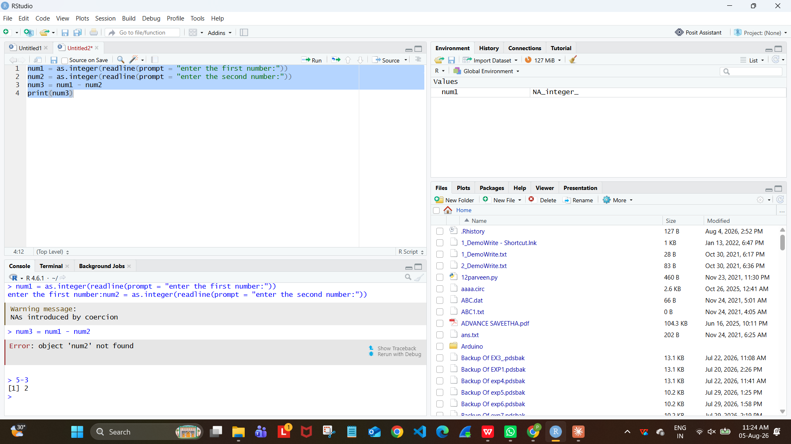

RESULT: Thus the R program for subtraction was executed successfully.

EXPERIMENT - 3:

AIM:
To write/prove the R program for multiplication using RStudio.

PROGRAM:
num1 = as.integer(readline(prompt = "enter the first number:"))
num2 = as.integer(readline(prompt = "enter the second number:"))
num3 = num1 * num2
print(num3)

OUTPUT:
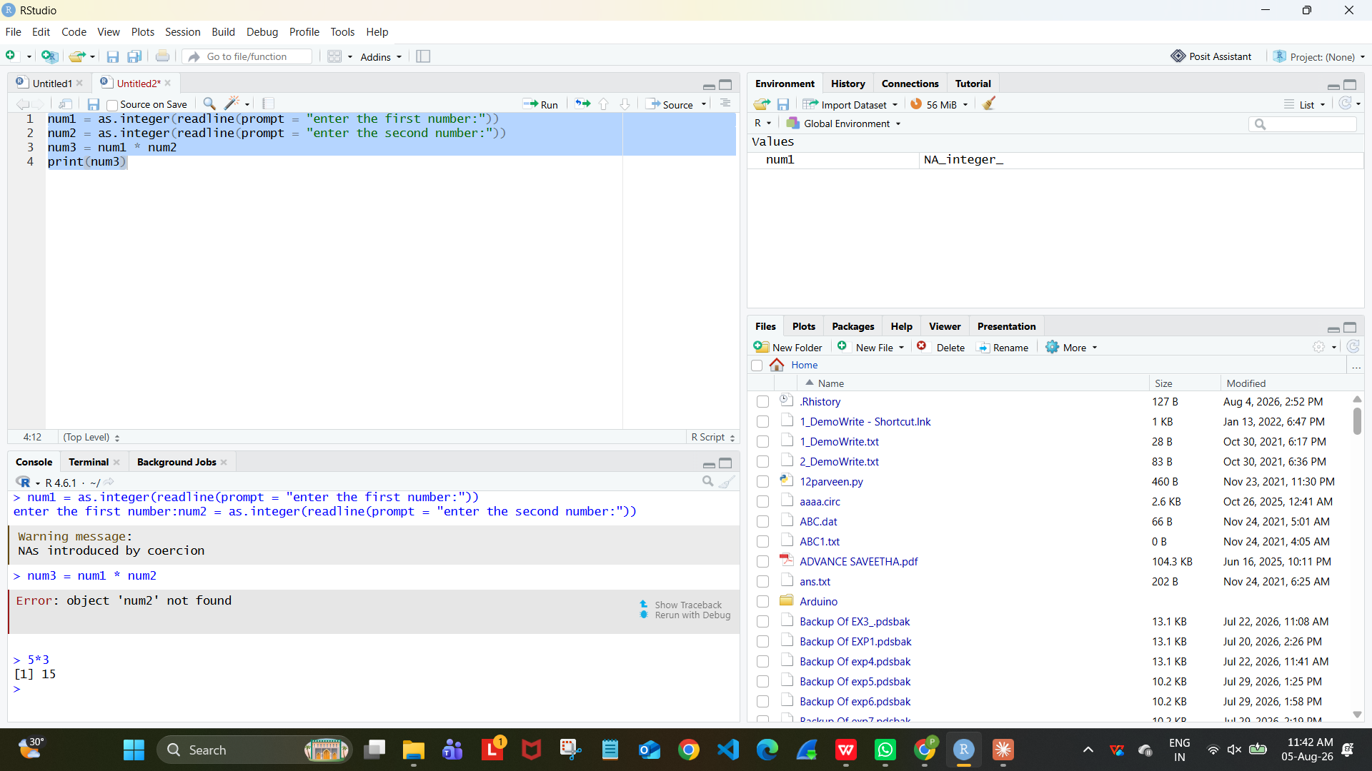

RESULT: Thus the R program for multiplication was executed successfully.

EXPERIMENT - 4:

AIM:
To write/prove the R program for division using RStudio.

PROGRAM:
num1 = as.integer(readline(prompt = "enter the first number:"))
num2 = as.integer(readline(prompt = "enter the second number:"))
num3 = num1 / num2
print(num3)

OUTPUT:
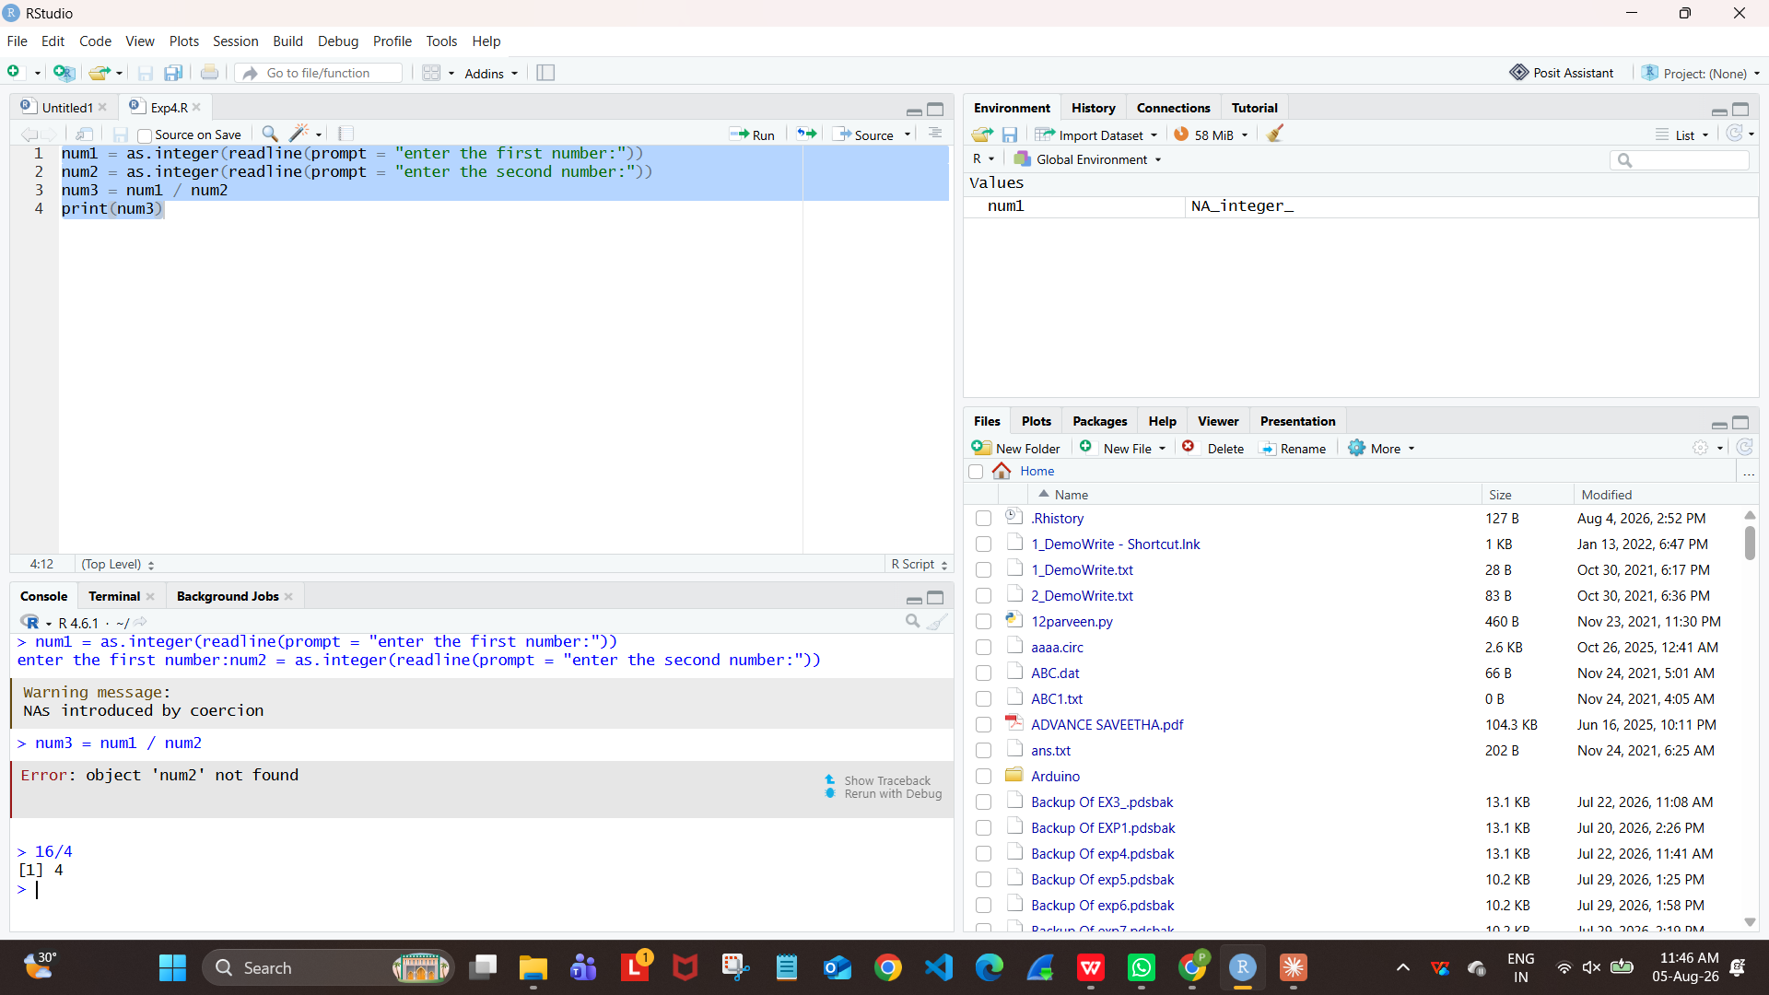

RESULT: Thus the R program for division was executed successfully.

EXPERIMENT - 5:

AIM:
To write/prove the R program for odd or even using RStudio.

PROGRAM:
num = as.integer(readline(prompt = "enter a number:"))
if ((num %% 2) == 0) {
print("number is even")
} else {
print("number is odd")
}

OUTPUT:
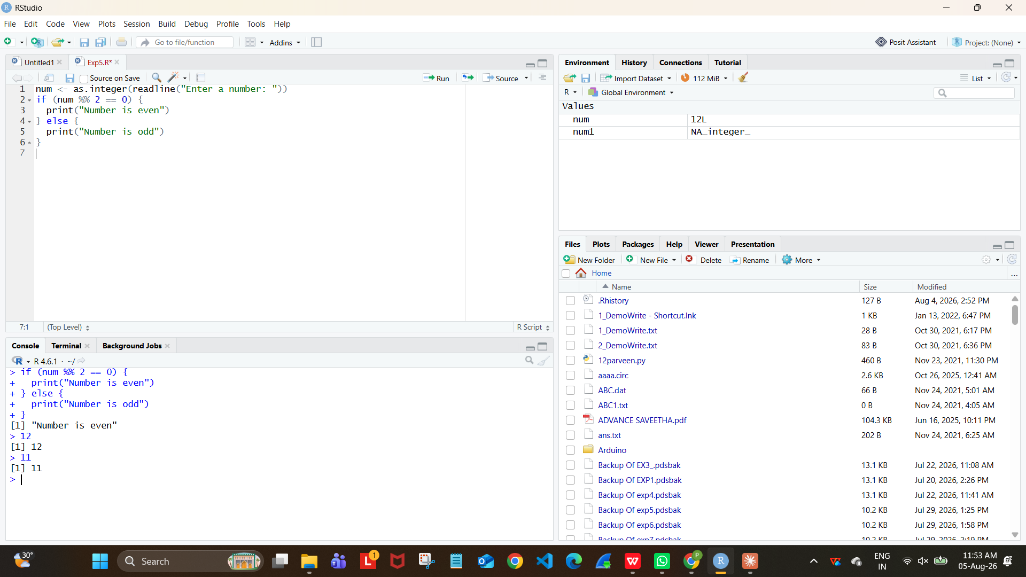

RESULT: Thus the R program to check odd or even was executed successfully.

EXPERIMENT - 6:

AIM:
To write/prove the R program for mean, median, mode using RStudio.

PROGRAM:
names <- c("siri", "mahi", "chiru")
age <- c(23, 24, 25)
marks <- c(88, 78, 25)
df <- data.frame(names, age, marks)
mean(df$age)
median(df$age)
mode(df$age)
write.csv(df, "datafr.csv")

OUTPUT:
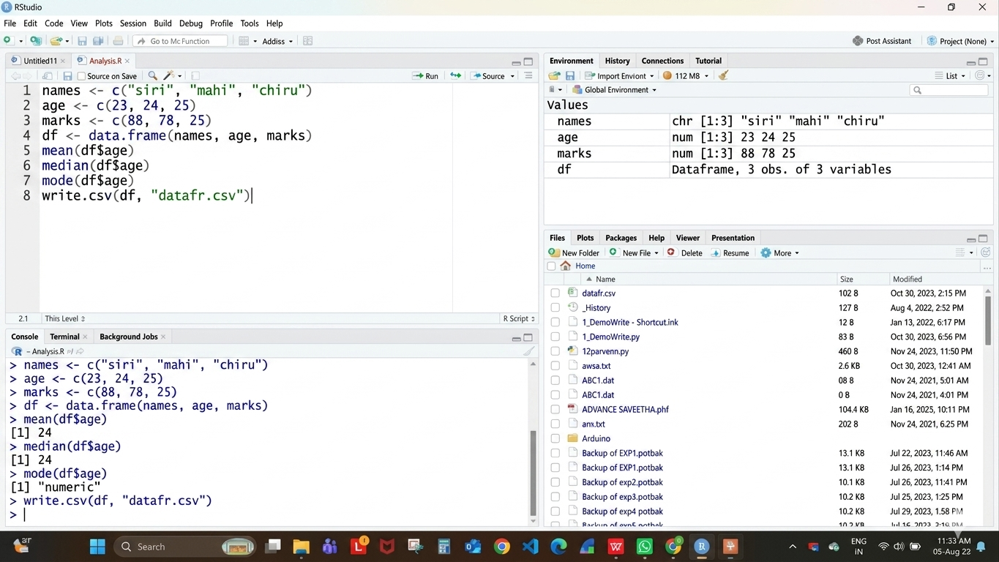

RESULT: Thus the program for mean, median and mode was executed successfully.

EXPERIMENT - 7:

AIM:
To write/prove the R program for summary using RStudio.

PROGRAM:
names <- c("siri", "mahi", "chiru")
age <- c(23, 24, 25)
marks <- c(88, 78, 25)
df <- data.frame(names, age, marks)
summary(df$age)
write.csv(df, "datafr.csv")

OUTPUT:
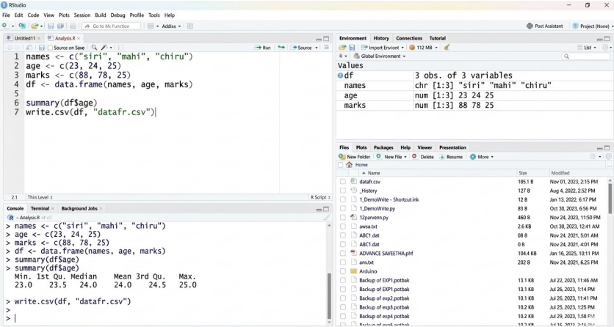

RESULT: Thus the program to compute summary statistics was executed successfully.

EXPERIMENT - 8:

AIM:
To write/prove the R program for greatest among three numbers using RStudio.

PROGRAM:
x <- as.integer(readline(prompt = "Enter first number :"))
y <- as.integer(readline(prompt = "Enter second number :"))
z <- as.integer(readline(prompt = "Enter third number :"))
if (x > y && x > z) {
print(paste("Greatest is :", x))
} else if (y > z) {
print(paste("Greatest is :", y))
} else {
print(paste("Greatest is :", z))
}

OUTPUT:
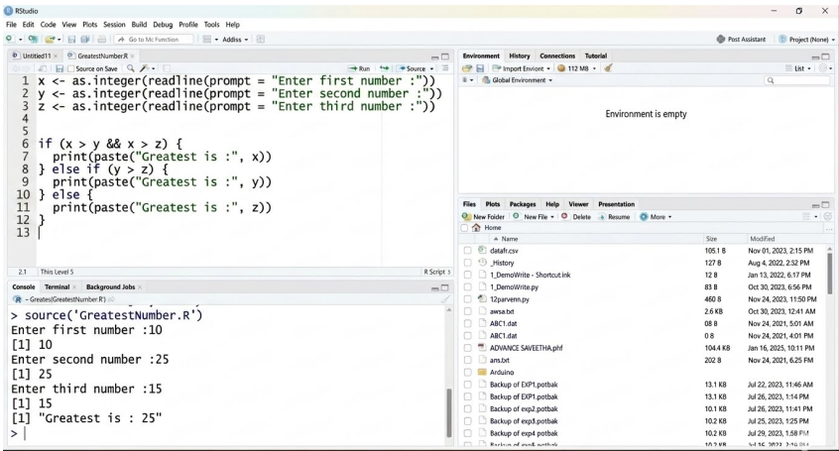

RESULT: Thus the program to find the greatest among three numbers was executed successfully.

EXPERIMENT - 9:

AIM:
To write/prove the R program for inter-quartile range (iqr) using RStudio.

PROGRAM:
names <- c("siri", "mahi", "chiru")
age <- c(23, 24, 25)
marks <- c(88, 78, 25)
df <- data.frame(names, age, marks)
IQR(df$age)
write.csv(df, "datafr.csv")

OUTPUT:
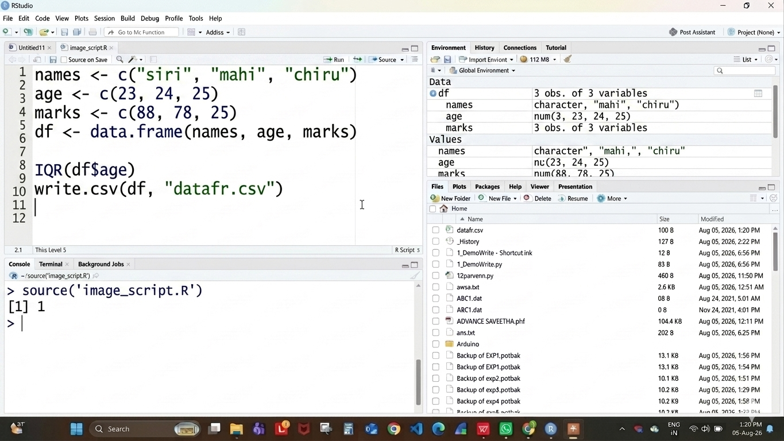

RESULT: Thus the program for central tendency and data dispersion (IQR) was executed successfully.

EXPERIMENT - 10:

AIM:
To write/prove the R program for quantile using RStudio.

PROGRAM:
names <- c("siri", "mahi", "chiru")
age <- c(23, 24, 25)
marks <- c(88, 78, 25)
df <- data.frame(names, age, marks)
quantile(df$age)
write.csv(df, "datafr.csv")

OUTPUT:
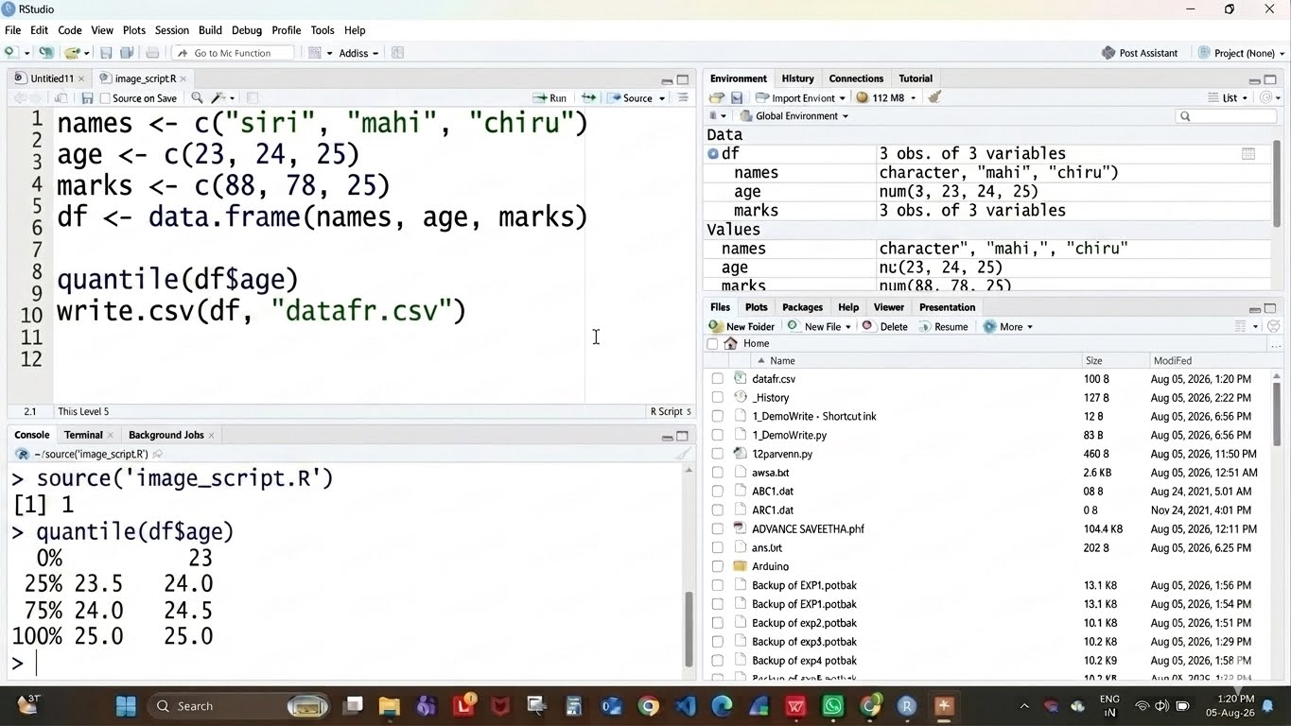

RESULT: Thus the program for central tendency and data dispersion (Quantile) was executed successfully.

EXPERIMENT – 11:
AIM:
To write/prove the R program for mid range using RStudio.

PROGRAM:
names <- c("siri", "mahi", "chiru")
age <- c(23, 24, 25)
marks <- c(88, 78, 25)
df <- data.frame(names, age, marks)
range(df$age)
write.csv(df, "datafr.csv")

OUTPUT:
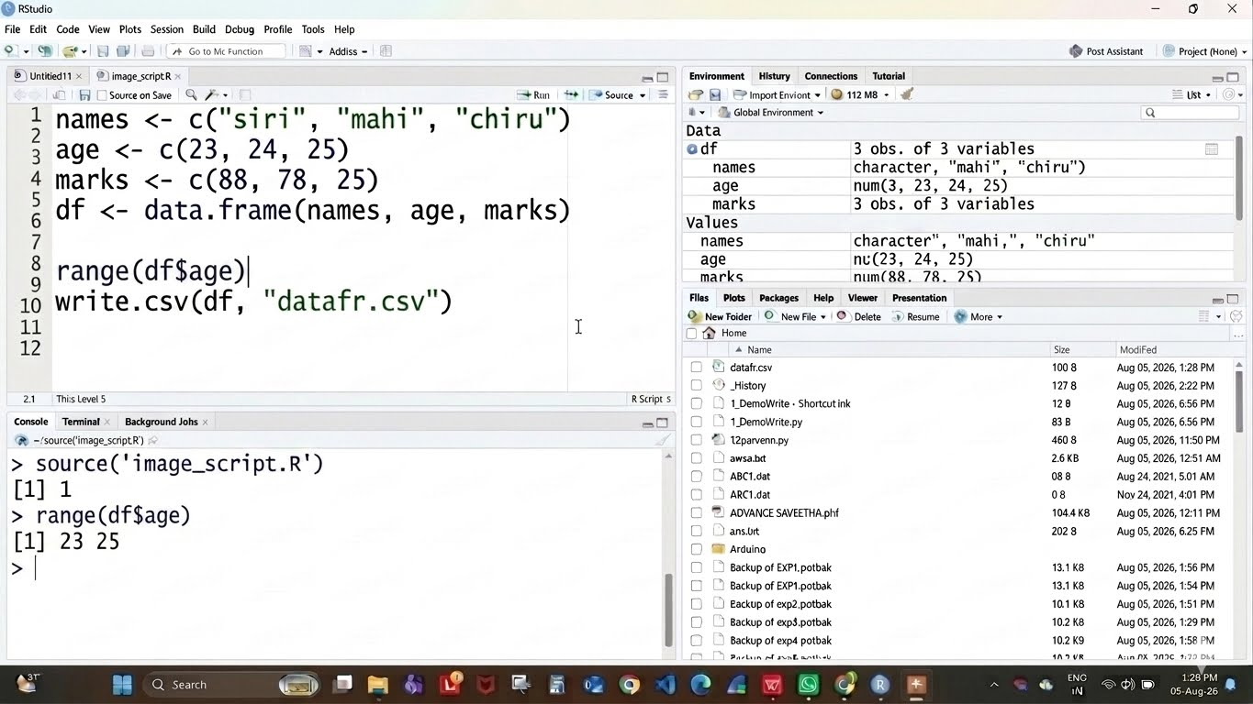

RESULT: Thus the program for central tendency and data dispersion (Mid Range) was executed successfully.

EXPERIMENT - 12:
AIM:
To write/prove the R program for z-score normalization using RStudio.

PROGRAM:
diabetest1 <- read_excel("C:/Users/M.Geetha/Downloads/NARA.xlsx")
A <- c(diabetest1$Age)
Mean <- mean(A)
Std <- sd(A)
Zscore <- (A - Mean) / Std
Zscore

OUTPUT:
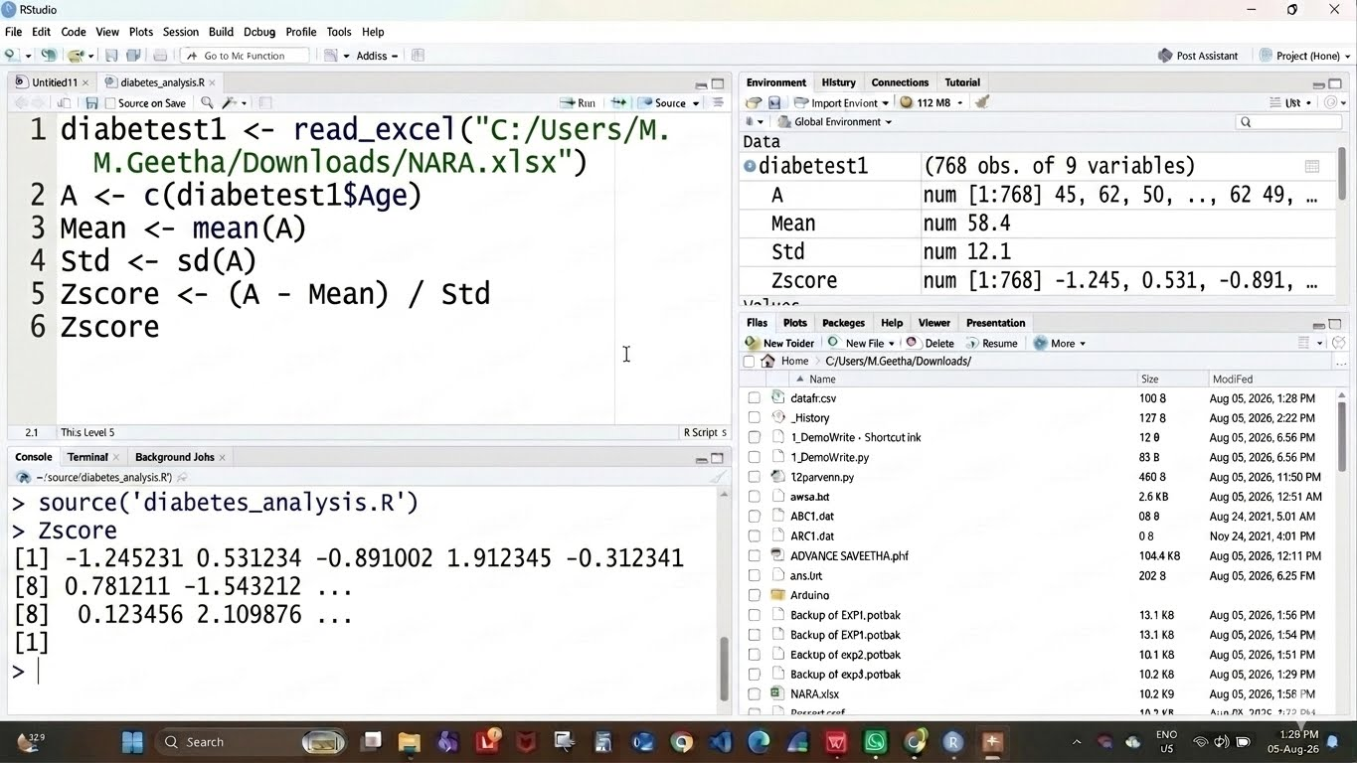

RESULT: Thus the Z-score normalization using R tool was executed successfully.

EXPERIMENT - 13:
AIM:
To write/prove the R program for min, max, mean, minmax using RStudio.

PROGRAM:
diabetest1 <- read_excel("C:/Users/M.Geetha/Downloads/NARA.xlsx")
A <- c(diabetest1$Age)
Mean <- mean(A)
Minimum <- min(diabetest1$Age)
Maximum <- max(diabetest1$Age)
MinMax <- (A - Minimum) / (Maximum - Minimum)
MinMax

OUTPUT:

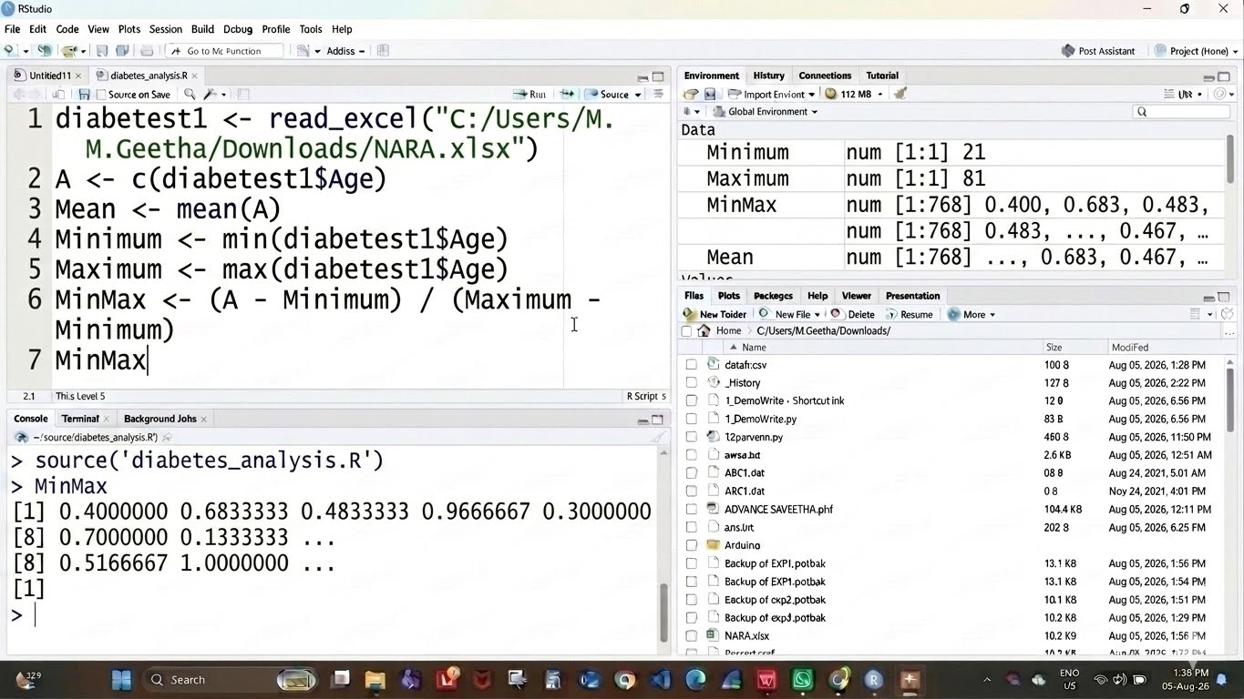

RESULT: Thus the program for min, max, mean and min-max normalization was executed successfully.

EXPERIMENT - 14:

AIM:
To write/prove the R program for bar plot and horizontal bar using RStudio.

PROGRAM:
a <- c(55, 67, 89, 80, 90)
barplot(a)
barplot(a, horiz = TRUE)

OUTPUT:
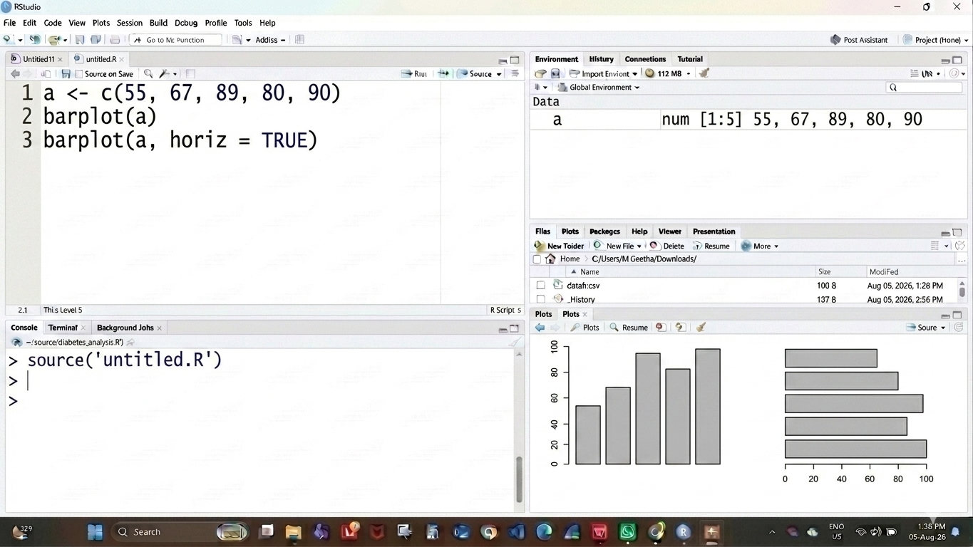

RESULT: Thus the bar plot and horizontal bar plot were drawn successfully.

EXPERIMENT - 15:

AIM:
To write/prove the R program for box plot using RStudio.

PROGRAM:
names <- c("siri", "chru", "loki")
age <- c(23, 24, 25)
marks <- c(88, 78, 25)
df <- data.frame(names, age, marks)
hist(df$age)
boxplot(df$age)

OUTPUT:
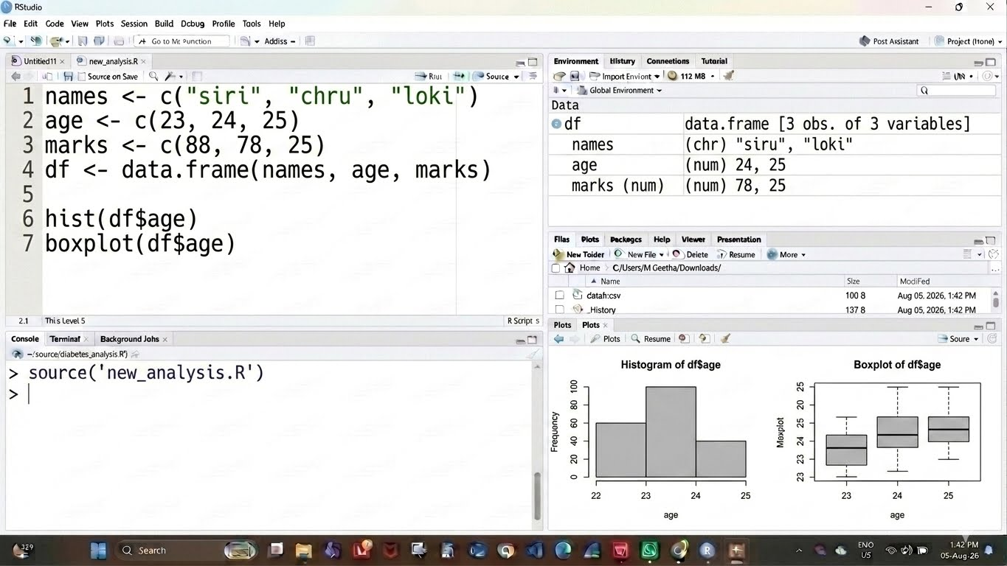

RESULT: Thus the box plot was drawn successfully.

EXPERIMENT - 16:

AIM:
To write/prove the R program for histogram using RStudio.

PROGRAM:
a <- c(55, 67, 89, 80, 90)
hist(a)

OUTPUT:
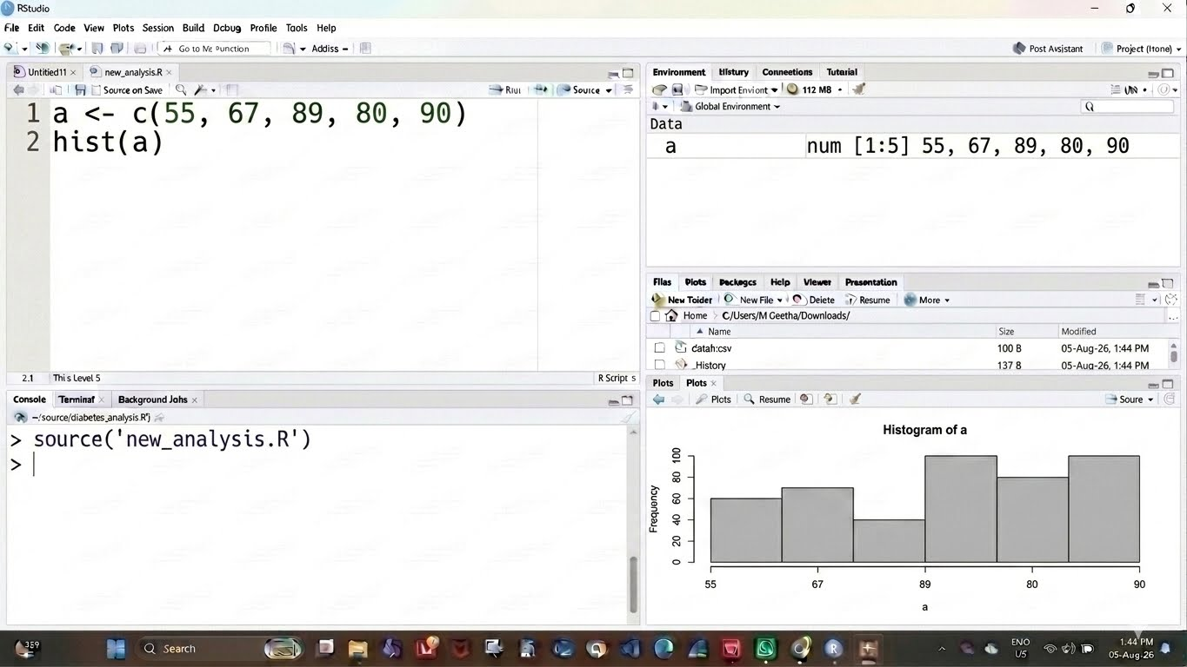

RESULT: Thus the histogram plot was drawn successfully.

EXPERIMENT - 17:

AIM:
To write/prove the R program for correlation analysis using RStudio.

PROGRAM:
diabetest1 <- read_excel("C:/Users/M.Geetha/Downloads/NARA.xlsx")
diabetest1 <- table(diabetest1$Age, diabetest1$Insulin)
diabetest1
chisq.test(diabetest1)

OUTPUT:
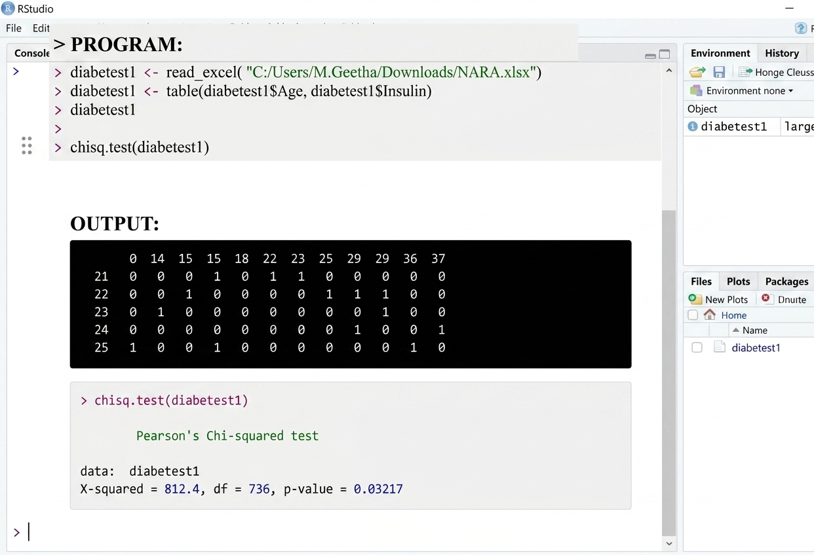

RESULT: Thus the correlation analysis using R tool was executed successfully.

EXPERIMENT - 18:

AIM:
To write/prove the R program for scatter plot using RStudio.

PROGRAM:
set.seed(9)
x <- rnorm(1000)
y <- rnorm(1000)
smoothScatter(y - x)
smoothScatter(x, y)

OUTPUT:
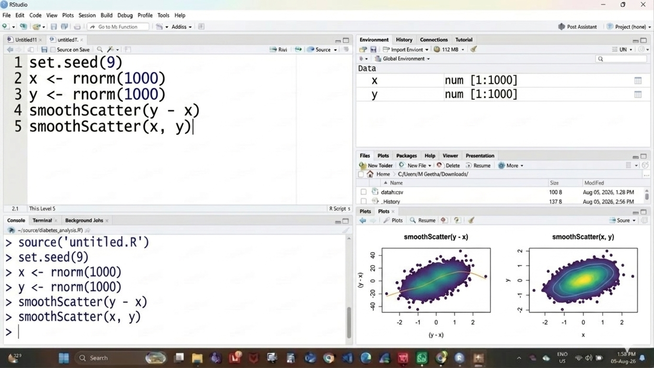

RESULT: Thus the scatter plot was drawn successfully.

EXPERIMENT - 19:

AIM:
To write/prove the R program for linear regression using RStudio.

PROGRAM:
Relation <- lm(diabetes$BloodPressure ~ diabetes$Age)
plot(diabetes$Age, diabetes$BloodPressure, col = "green",
main = "Linear Regression Analysis",
xlab = "Age", ylab = "BloodPressure")
abline(lm(diabetes$BloodPressure ~ diabetes$Age))

OUTPUT:
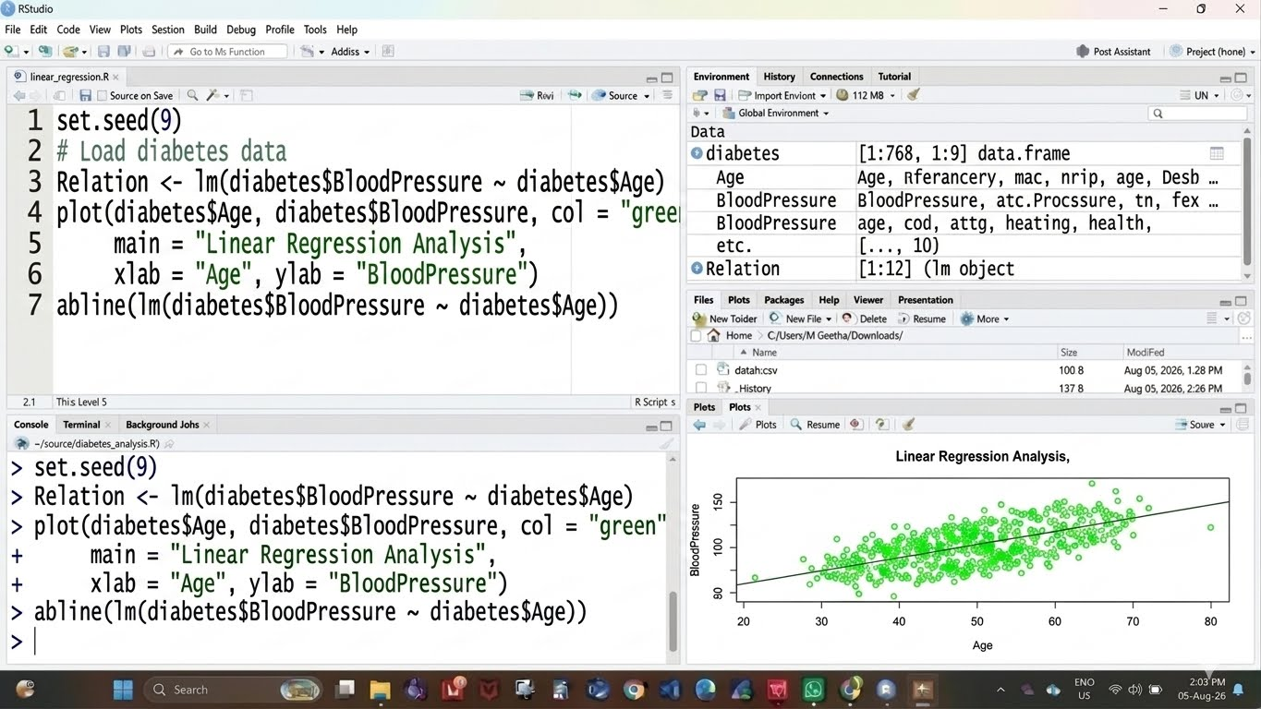

RESULT: Thus the linear regression program was executed successfully.

EXPERIMENT - 20:

AIM:
To write/prove the R program for multiple regression using RStudio.

PROGRAM:
input <- diabetes[, c("Age", "BloodPressure", "Glucose")]
model <- lm(Age ~ BloodPressure + Glucose, data = input)
print(model)
A <- coef(model)[1]
xBloodPressure <- coef(model)[2]
yGlucose <- coef(model)[3]
print(A); print(xBloodPressure); print(yGlucose)
y <- A + xBloodPressure + yGlucose
print(y)

OUTPUT:
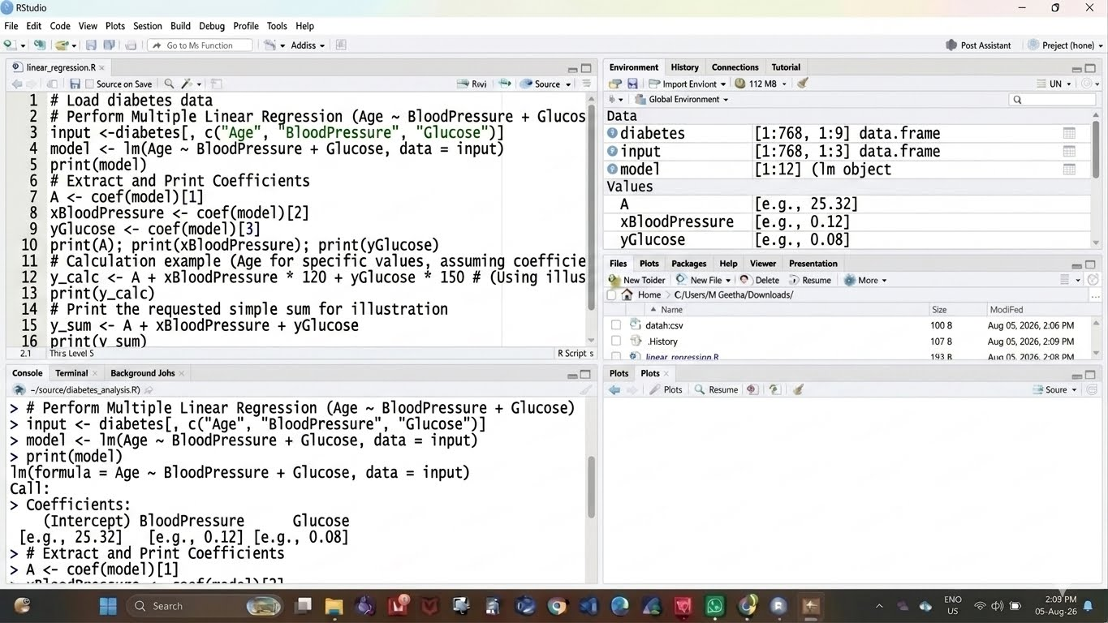
RESULT: Thus the multiple regression program was executed successfully.

